COMPUTATIONAL METHOD
LAB FILE



MAHARAJA SURAJMAL INSTITUTE OF TECHNOLOGY
C4 , Janakpuri, New Delhi – 110058
Electronics and Communication Engineering Department

Name:- Rishi Parkash Verma
Class Serial No.:- 24
Enrollment No.:- 03315002825
Class:- ECE — 1
Submitted To:
Dr. Gitanjali
Dr. Deeba Naqvi

INDEX
Exp no. | Date | Practical name | Page no. | Teacher’s sign | Remarks

Practical : 1 (a)
Linear equation in 1 variable
Aim : Program to find value of x in Linear equation.
Code :
#include <stdio.h>

int main() {
float a, b, x;
printf("Equation: ax + b = 0\n");
printf("Enter a and b: ");
scanf("%f %f", &a, &b);
if (a == 0) {
printf("Not a linear equation (a=0).\n");
} else {
x = -b / a;
printf("Solution: x = %.2f\n", x);
}
return 0;
}

Output:

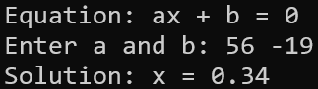

Practical : 1 (b)
Linear equation in 2 variable
Aim : Program to find value of x,y in Linear equation.
Code:
#include <stdio.h>

int main() {
float a1, b1, c1, a2, b2, c2, x, y, det;
printf("Write two Equations in ax + by = c form\n");
printf("Enter a1, b1, c1: ");
scanf("%f %f %f", &a1, &b1, &c1);
printf("Enter a2, b2, c2: ");
scanf("%f %f %f", &a2, &b2, &c2);
printf("Equations are:\n");
printf("%.2fx %c %.2fy = %.2f\n", a1, b1 >= 0 ? '+' : '-', b1 >= 0 ? b1 :
b1, c1);
printf("%.2fx %c %.2fy = %.2f\n", a2, b2 >= 0 ? '+' : '-', b2 >= 0 ? b2 :
b2, c2);
//cramer's rule
det = a1 * b2 - a2 * b1;
if (det == 0) {
printf("No unique solution exists.\n");
} else {
x = (c1 * b2 - c2 * b1) / det;
y = (a1 * c2 - a2 * c1) / det;
printf("Solution: x = %.2f, y = %.2f\n", x, y);
}
return 0;
}

Output:

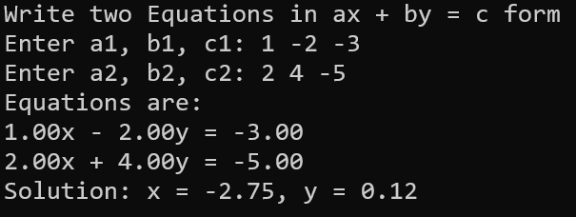

Practical : 1 (c)
Quadratic Equation
Aim : Program to find value of x in Quadratic equation.
Code:
#include <stdio.h>
#include <math.h>

int main() {
float a, b, c, Det, r1, r2, realPart, imagPart;
printf("Equation: ax^2 + bx + c = 0\n");
printf("Enter a, b, c: ");
scanf("%f %f %f", &a, &b, &c);
printf("%.2fx^2 %c %.2fx %c %.2f = 0\n", a,
b >= 0 ? '+' : '-', b >= 0 ? b : -b,
c >= 0 ? '+' : '-', c >= 0 ? c : -c);

Det = b * b - 4 * a * c;

if (Det > 0) {
r1 = (-b + sqrt(Det)) / (2 * a);
r2 = (-b - sqrt(Det)) / (2 * a);
printf("Roots are real and distinct: %.2f and %.2f\n", r1, r2);
} else if (Det == 0) {
r1 = -b / (2 * a);
printf("Roots are real and equal: %.2f and %.2f\n", r1, r1);
} else {
realPart = -b / (2 * a);
if (fabs(realPart) < 0.001)
realPart = 0;
imagPart = fabs(sqrt(-Det) / (2 * a));
printf("Roots are complex: %.2f + %.2fi and %.2f - %.2fi\n", realPart,
imagPart, realPart, imagPart);
}
return 0;
}

Output:
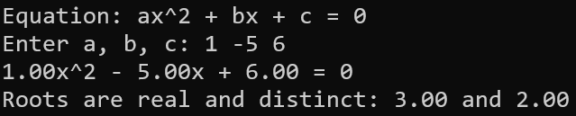
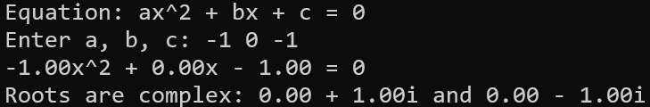

Practical : 2
Bisection Method
Aim : Program for finding roots of f(x)=0 Bisection method.
Code:
#include <math.h>
#include <stdio.h>

float A, B, C, D;

float f(float x) {
return ((A * x + B) * x + C) * x + D;
}

int main() {
float a, b, mid, root1, e = 0.000001;
float p, q, r, d, root2, root3;
int iter = 0;

printf("Cubic equation: Ax^3 + Bx^2 + Cx + D = 0\n");
printf("Enter A, B, C, D: ");
if (scanf("%f %f %f %f", &A, &B, &C, &D) != 4 || A == 0) {
printf("Invalid cubic coefficients.\n");
return 1;
}

printf("Enter interval for first root: ");
if (scanf("%f %f", &a, &b) != 2 || f(a) * f(b) > 0) {
printf("Invalid interval\n");
return 1;
}

do {
mid = (a + b) / 2;
iter++;
if (f(a) * f(mid) < 0)
b = mid;
else
a = mid;
} while (fabs(f(mid)) > e);

root1 = mid;
printf("Iterations took %d \n", iter);
printf("First root (bisection): %.6f\n", root1);

p = A;
q = B + A * root1;
r = C + q * root1;
d = q * q - 4 * p * r;

if (d >= 0) {
root2 = (-q + sqrt(d)) / (2 * p);
root3 = (-q - sqrt(d)) / (2 * p);
printf("Second root: %.6f\n", root2);
printf("Third root: %.6f\n", root3);
} else {
float real = -q / (2 * p);
float imag = sqrt(-d) / fabs(2 * p);
printf("Second root: %.6f + %.6fi\n", real, imag);
printf("Third root: %.6f - %.6fi\n", real, imag);
}

return 0;
}

Output:
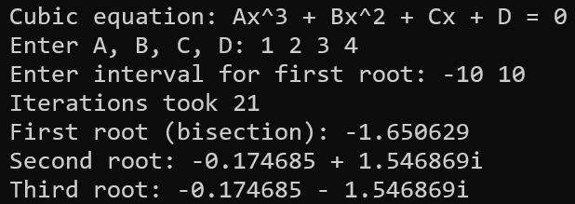

Practical : 3
Secant Method
Aim : Program for finding roots of f(x)=0 Secant method.
Code:
#include <math.h>
#include <stdio.h>

float A, B, C, D;

float f(float x) {
return ((A * x + B) * x + C) * x + D;
}

int main() {
float x0, x1, x2, e = 0.000001;
float p, q, r, d, root2, root3;
int iter = 0;

printf("Cubic equation: Ax^3 + Bx^2 + Cx + D = 0\n");
printf("Enter A, B, C, D: ");
if (scanf("%f %f %f %f", &A, &B, &C, &D) != 4 || A == 0) {
printf("Invalid cubic coefficients.\n");
return 1;
}

printf("Enter initial guesses: ");
if (scanf("%f %f", &x0, &x1) != 2 || (f(x0) - f(x1)) == 0) {
printf("Invalid initial guesses.\n");
return 1;
}

do {
x2 = (f(x1) * x0 - f(x0) * x1) / (f(x1) - f(x0));
iter++;
x0 = x1;
x1 = x2;
} while (fabs(f(x2)) > e);
printf("Iterations took %d \n", iter);
printf("First Root is : %f\n", x2);

p = A;
q = B + A * x2;
r = C + q * x2;
d = q * q - 4 * p * r;

if (d >= 0) {
root2 = (-q + sqrt(d)) / (2 * p);
root3 = (-q - sqrt(d)) / (2 * p);
printf("Second root: %.6f\n", root2);
printf("Third root: %.6f\n", root3);
} else {
float real = -q / (2 * p);
if (fabs(real) < 0.000001)
real = 0;
float imag = sqrt(-d) / fabs(2 * p);
printf("Second root: %.6f + %.6fi\n", real, imag);
printf("Third root: %.6f - %.6fi\n", real, imag);
}

return 0;
}

Output:
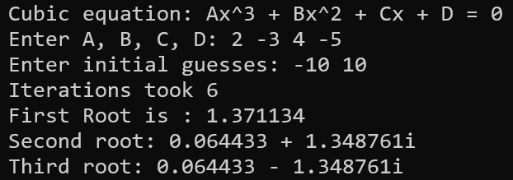

Practical : 4
Newton Raphson Method
Aim: Program for finding roots of f(x)=0 Newton Raphson method.
Code:
#include <math.h>
#include <stdio.h>

float A, B, C, D;

float f(float x) {
return ((A * x + B) * x + C) * x + D;
}

float df(float x) {
return (3 * A * x * x) + (2 * B * x) + C;
}

int main() {
float x0, x1, e = 0.000001;
float p, q, r, d, root2, root3;
int iter = 0;

printf("Newton-Raphson Method for Ax^3 + Bx^2 + Cx + D = 0\n");
printf("Enter A, B, C, D: ");
if (scanf("%f %f %f %f", &A, &B, &C, &D) != 4 || A == 0) {
printf("Invalid cubic coefficients.\n");
return 1;
}

printf("Enter initial guess: ");
if (scanf("%f", &x0) != 1) {
printf("Invalid initial guess.\n");
return 1;
}

do {
if (df(x0) == 0) {
printf("Derivative is zero. Cannot continue.\n");
return 1;
}
x1 = x0 - f(x0) / df(x0);
iter++;
x0 = x1;
} while (fabs(f(x1)) > e);

printf("Iterations took %d\n", iter);
printf("First root: %.6f\n", x1);

p = A;
q = B + A * x1;
r = C + q * x1;
d = q * q - 4 * p * r;

if (d >= 0) {
root2 = (-q + sqrt(d)) / (2 * p);
root3 = (-q - sqrt(d)) / (2 * p);
printf("Second root: %.6f\n", root2);
printf("Third root: %.6f\n", root3);
} else {
float real = -q / (2 * p);
if (fabs(real) < e)
real = 0;
float imag = sqrt(-d) / fabs(2 * p);
printf("Second root: %.6f + %.6fi\n", real, imag);
printf("Third root: %.6f - %.6fi\n", real, imag);
}
return 0;
}

Output:
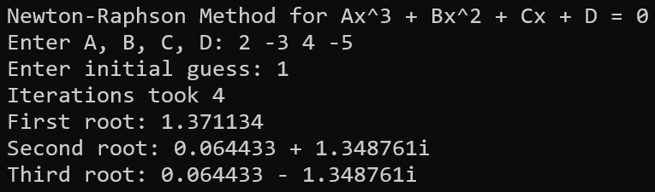

Practical : 5
Matrix Operations
Aim: Program to perform basic Matrix Operations.
- Addition
- Subtraction
- Multiplication
- Inverse
- Adjoint
- Determinant
- Eigenvalues
- Simultaneous Equations
- Orthogonal Check
Code:
#include <math.h>
#include <stdio.h>
#define Max 10

float determinant_calc(float a[Max][Max], int n) {
if (n == 1) return a[0][0];
if (n == 2) return a[0][0] * a[1][1] - a[0][1] * a[1][0];
float det = 0, sub[Max][Max];
int sign = 1;
for (int x = 0; x < n; x++) {
int subi = 0;
for (int i = 1; i < n; i++) {
int subj = 0;
for (int j = 0; j < n; j++) {
if (j == x) continue;
sub[subi][subj++] = a[i][j];
}
subi++;
}
det += sign * a[0][x] * determinant_calc(sub, n - 1);
sign = -sign;
}
return det;
}

void getCofactor(float a[Max][Max], float temp[Max][Max], int p, int q, int n) {
int i = 0, j = 0;
for (int row = 0; row < n; row++) {
for (int col = 0; col < n; col++) {
if (row == p || col == q) continue;
temp[i][j++] = a[row][col];
if (j == n - 1) { j = 0; i++; }
}
}
}

void adjoint_calc(float a[Max][Max], float adj[Max][Max], int n) {
if (n == 1) { adj[0][0] = 1; return; }
int sign = 1; float temp[Max][Max];
for (int i = 0; i < n; i++) {
for (int j = 0; j < n; j++) {
getCofactor(a, temp, i, j, n);
sign = ((i + j) % 2 == 0) ? 1 : -1;
adj[j][i] = (sign) * (determinant_calc(temp, n - 1));
}
} }
void input_matrix(float a[Max][Max], int* r, int* c, int is_square) {
printf("Enter rows and columns: ");
if (is_square) {
if (scanf("%d", r) != 1) return;
*c = *r;
} else {
if (scanf("%d %d", r, c) != 2) return;
}
printf("Enter elements: ");
for (int i = 0; i < *r; i++)
for (int j = 0; j < *c; j++)
if (scanf("%f", &a[i][j]) != 1) return;
}
void addition() {
float a[Max][Max], b[Max][Max]; int r, c;
printf("Enter rows and columns: ");
if (scanf("%d %d", &r, &c) != 2) return;
printf("Enter first matrix\nEnter elements: ");
for (int i = 0; i < r; i++)
for (int j = 0; j < c; j++)
if (scanf("%f", &a[i][j]) != 1) return;
printf("Enter second matrix\nEnter elements: ");
for (int i = 0; i < r; i++)
for (int j = 0; j < c; j++)
if (scanf("%f", &b[i][j]) != 1) return;
printf("Sum:\n");
for (int i = 0; i < r; i++) {
for (int j = 0; j < c; j++) printf("%.2f ", a[i][j] + b[i][j]);
printf("\n");
}
}

void subtraction() {
float a[Max][Max], b[Max][Max]; int r, c;
printf("Enter rows and columns: ");
if (scanf("%d %d", &r, &c) != 2) return;
printf("Enter first matrix\nEnter elements: ");
for (int i = 0; i < r; i++)
for (int j = 0; j < c; j++)
if (scanf("%f", &a[i][j]) != 1) return;
printf("Enter second matrix\nEnter elements: ");
for (int i = 0; i < r; i++)
for (int j = 0; j < c; j++)
if (scanf("%f", &b[i][j]) != 1) return;
printf("Difference:\n");
for (int i = 0; i < r; i++) {
for (int j = 0; j < c; j++) printf("%.2f ", a[i][j] - b[i][j]);
printf("\n");
}
}

void multiplication() {
float a[Max][Max], b[Max][Max], mul[Max][Max] = { 0 }; int r1, c1, r2, c2;
printf("Enter first matrix\n");
input_matrix(a, &r1, &c1, 0);
printf("Enter second matrix\n");
input_matrix(b, &r2, &c2, 0);
if (c1 != r2) {
printf("Cannot multiply.\n");
return;
}
printf("Product:\n");
for (int i = 0; i < r1; i++) {
for (int j = 0; j < c2; j++) {
for (int k = 0; k < c1; k++) mul[i][j] += a[i][k] * b[k][j];
printf("%.2f ", mul[i][j]);
}
printf("\n");
}
}

void inverse() {
float a[Max][Max], adj[Max][Max]; int n;
printf("Enter the matrix\n");
input_matrix(a, &n, &n, 1);
float det = determinant_calc(a, n);
if (det == 0) printf("Inverse does not exist.\n");
else {
adjoint_calc(a, adj, n); printf("Inverse:\n");
for (int i = 0; i < n; i++) {
for (int j = 0; j < n; j++) printf("%.4f ", adj[i][j] / det);
printf("\n");
}
}
}

void adjoint_op() {
float a[Max][Max], adj[Max][Max]; int n;
printf("Enter the matrix\n");
input_matrix(a, &n, &n, 1); adjoint_calc(a, adj, n);
printf("Adjoint:\n");
for (int i = 0; i < n; i++) {
for (int j = 0; j < n; j++) printf("%.4f ", adj[i][j]);
printf("\n");
}
}

void determinant() {
float a[Max][Max]; int n;
printf("Enter the matrix\n");
input_matrix(a, &n, &n, 1);
printf("Determinant = %.4f\n", determinant_calc(a, n));
}

void eigenvalue() {
float a[Max][Max], x[Max], nx[Max]; int n;
printf("Enter the matrix\n");
input_matrix(a, &n, &n, 1);
printf("Enter initial guess vector: ");
for (int i = 0; i < n; i++)
if (scanf("%f", &x[i]) != 1)
return;
float lambda = 0, lambda_old = 0, max_val; int iter = 0;
do {
lambda_old = lambda;
for (int i = 0; i < n; i++) {
nx[i] = 0; for (int j = 0; j < n; j++) nx[i] += a[i][j] * x[j];
}
max_val = fabs(nx[0]);
for (int i = 1; i < n; i++) if (fabs(nx[i]) > max_val) max_val = fabs(nx[i]);
lambda = max_val;
for (int i = 0; i < n; i++) x[i] = nx[i] / lambda;
iter++;
} while (fabs(lambda - lambda_old) > 0.0001 && iter < 1000);
printf("Dominant Eigenvalue: %.4f\n", lambda);
}

void simultaneous_equations() {
float a[Max][Max + 1]; int n;
printf("Enter number of variables: ");
if (scanf("%d", &n) != 1)
return;
printf("Enter augmented matrix: ");
for (int i = 0; i < n; i++)
for (int j = 0; j < n + 1; j++)
if (scanf("%f", &a[i][j]) != 1)
return;
for (int i = 0; i < n; i++) {
if (a[i][i] == 0.0)
return;
for (int j = 0; j < n; j++) {
if (i != j) {
float ratio = a[j][i] / a[i][i];
for (int k = 0; k < n + 1; k++) a[j][k] = a[j][k] - ratio * a[i][k];
}
}
}
printf("Solutions:\n");
for (int i = 0; i < n; i++) printf("x%d = %.4f\n", i + 1, a[i][n] / a[i][i]);
}

void orthogonal() {
float a[Max][Max], mul[Max][Max] = { 0 }; int n, isOrtho = 1;
printf("Enter the matrix\n");
input_matrix(a, &n, &n, 1);
for (int i = 0; i < n; i++)
for (int j = 0; j < n; j++)
for (int k = 0; k < n; k++) mul[i][j] += a[i][k] * a[j][k];
for (int i = 0; i < n; i++) {
for (int j = 0; j < n; j++) {
if (i == j && (mul[i][j] < 0.999 || mul[i][j] > 1.001)) isOrtho = 0;
if (i != j && (mul[i][j] < -0.001 || mul[i][j] > 0.001)) isOrtho = 0;
}
}
printf(isOrtho ? "Matrix is Orthogonal.\n" : "Matrix is NOT Orthogonal.\n");
}

int main() {
int choice;
do {
printf("\n==== Matrix Operations Combined ====\n");
printf("1. Addition\n2. Subtraction\n3. Multiplication\n4. Inverse\n5.
Adjoint\n6. Determinant\n7. Eigenvalues\n8. Simultaneous Equations\n9.
Orthogonal Check\n0. Exit\nEnter your choice: ");
if (scanf("%d", &choice) != 1) break;
if (choice == 1) addition();
else if (choice == 2) subtraction();
else if (choice == 3) multiplication();
else if (choice == 4) inverse();
else if (choice == 5) adjoint_op();
else if (choice == 6) determinant();
else if (choice == 7) eigenvalue();
else if (choice == 8) simultaneous_equations();
else if (choice == 9) orthogonal();
else if (choice == 0) printf("Exiting...\n");
else printf("Invalid choice!\n");
} while (choice != 0);
return 0;
}

Output:

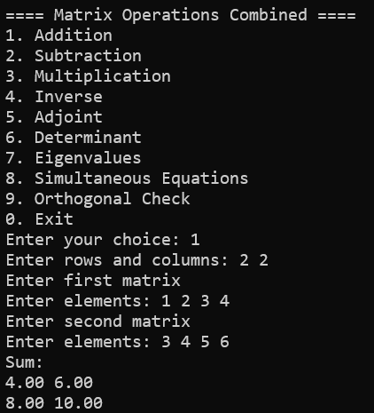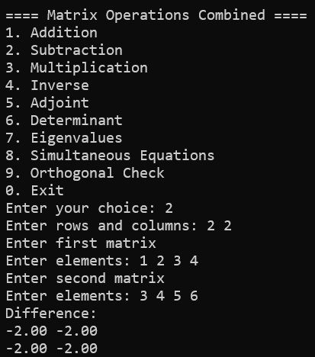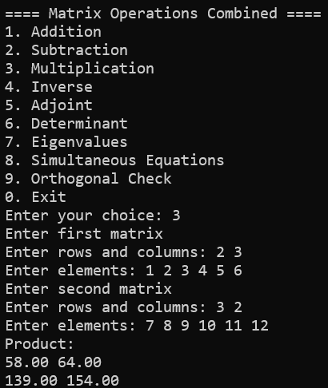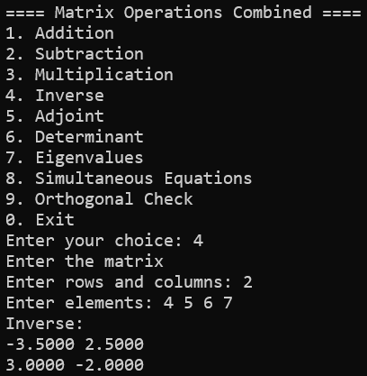
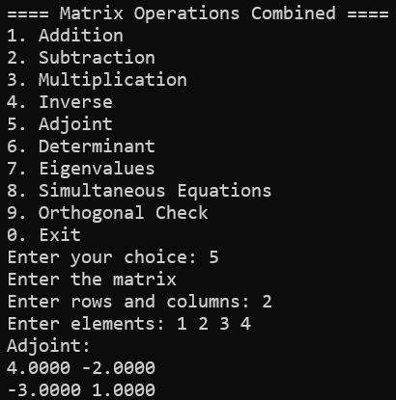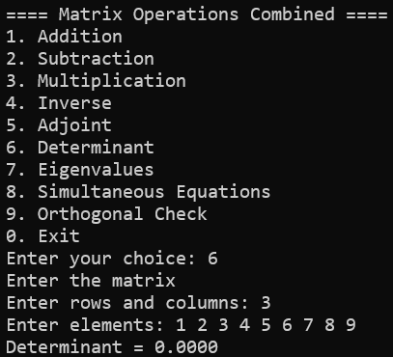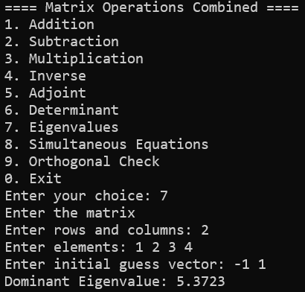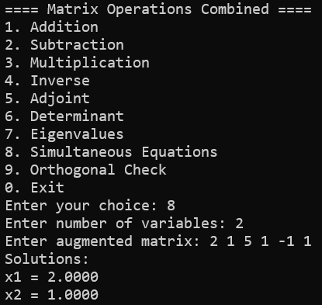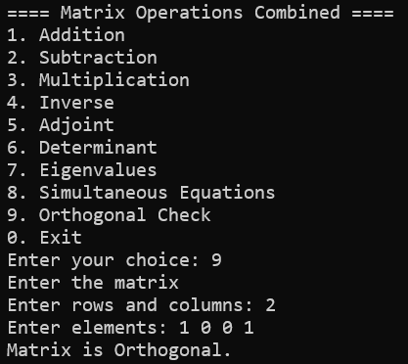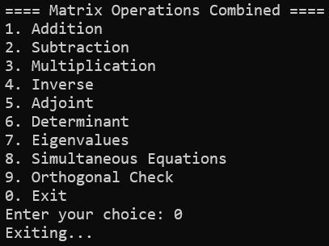

Practical : 6
Lagrange’s Interpolation
Aim: Program to implement Langrange’s Interpolation formula.
Code:
#include <stdio.h>

#define MAXN 10

float cx[MAXN], cy[MAXN];

float f1(float x, float pointx[], int i, int n) {
float numer = 1.0, deno = 1.0;
for (int j = 0; j < n; j++) {
if (j != i) {
numer = numer * (x - pointx[j]);
deno = deno * (pointx[i] - pointx[j]);
}
}
return numer / deno;
}

float f2(float x, float pointx[], float pointy[], int n) {
float sume = 0.0;
for (int i = 0; i < n; i++) {
sume = sume + f1(x, pointx, i, n) * pointy[i];
}
return sume;
}

int main() {
int n;
float x, result;
printf("Enter number of data points: ");
scanf("%d", &n);
if (n <= 0 || n > MAXN) {
printf("Invalid number of points.\n");
return 1;
}
printf("Enter x and y values:\n");
for (int i = 0; i < n; i++) {
printf("x%d y%d: ", i, i);
scanf("%f %f", &cx[i], &cy[i]);
}

printf("Enter the x value to interpolate: ");
scanf("%f", &x);
result = f2(x, cx, cy, n);
printf("Interpolated value = %.4f\n", result);

return 0;
}

Output:
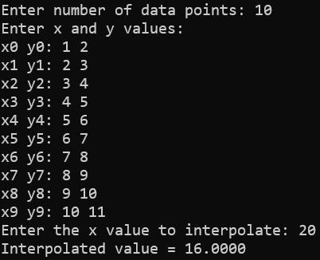

Practical : 7
Newton’s Forward Interpolation
Aim: Program to implement Newton’s Forward Interpolation formula.
Code:
#include <stdio.h>

#define MAXN 20

float absolute_value(float number) {
return number < 0.0f ? -number : number;
}

float larger_value(float first, float second) {
return first > second ? first : second;
}

int main(void) {
int n;
float x[MAXN], difference[MAXN][MAXN];
float value, h, u, term, result;

printf("Newton Forward Interpolation\n");
printf("Enter number of data points (2-%d): ", MAXN);
if (scanf("%d", &n) != 1 || n < 2 || n > MAXN) {
printf("Invalid number of data points.\n");
return 1;
}

printf("Enter x and y values:\n");
for (int i = 0; i < n; i++) {
printf("x[%d] y[%d]: ", i, i);
if (scanf("%f %f", &x[i], &difference[i][0]) != 2) {
printf("Invalid input.\n");
return 1;
}
}

h = x[1] - x[0];
if (absolute_value(h) < 1e-12f) {
printf("Invalid data: x values must be distinct.\n");
return 1;
}
for (int i = 2; i < n; i++) {
if (absolute_value((x[i] - x[i - 1]) - h) >
1e-9f * larger_value(1.0f, absolute_value(h))) {
printf("Invalid data: x values must be equally spaced.\n");
return 1;
}
}

for (int order = 1; order < n; order++) {
for (int row = 0; row < n - order; row++) {
difference[row][order] =
difference[row + 1][order - 1] - difference[row][order - 1];
}
}

printf("\n========================================\n");
printf(" Forward Difference Table\n");
printf("========================================\n");
printf(" %10s ", "x");
for (int order = 0; order < n; order++) {
char label[20];
if (order == 0)
snprintf(label, sizeof(label), "y");
else
snprintf(label, sizeof(label), "Δ^%d y", order);
printf("| %10s ", label);
}
printf("|\n");
printf("----------------------------------------\n");

for (int row = 0; row < n; row++) {
printf(" %10.4f ", x[row]);
for (int order = 0; order < n - row; order++) {
printf("| %10.4f ", difference[row][order]);
}
for (int order = n - row; order < n; order++) {
printf("| %10s ", "");
}
printf("|\n");
printf("----------------------------------------\n");
}

printf("\nNewton Forward Polynomial:\n");
printf("P(x) = %.6f", difference[0][0]);
for (int order = 1; order < n; order++) {
if (absolute_value(difference[0][order]) < 1e-12f) {
continue;
}
printf("\n + (%.6f)", difference[0][order]);
for (int factor = 0; factor < order; factor++) {
printf("(x - %.6f)", x[factor]);
}
printf("/(%d! * %.6f^%d)", order, h, order);
}
printf("\n");

printf("\nEnter the x value to interpolate: ");
if (scanf("%f", &value) != 1) {
printf("Invalid input.\n");
return 1;
}

u = (value - x[0]) / h;
result = difference[0][0];
term = 1.0f;

for (int order = 1; order < n; order++) {
term *= (u - (order - 1)) / order;
result += term * difference[0][order];
}

printf("Interpolated value at x = %.4f is %.6f\n", value, result);
return 0;
}

Output: 